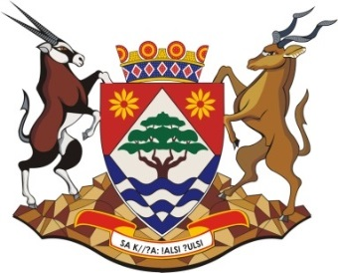

OFFICE OF THE PREMIER
TRAVEL MANAGEMENT SERVICES

BID PO 01/04/2021

NO. | COMPANY NAME
 | U4NIA TRAVEL
 | FREE STATE TRAVEL
 | ZILKO TRAVEL & TOURS
 | MUREX TRAVEL JV SS VISIONS
 | EXILITE TRAVEL
 | XL ASTRA TRAVEL
 | CITY OF CHOICE TRAVEL
 | OLEBELO TRAVEL
 | KENROSE TRAVEL
 | XCHANGE TRAVEL

